Build and modernize AI apps – Rich Customer Experience Apps with Cosmos DB (AI design wins)

Hero products
- Azure AI Services (OpenAI, Voice, AI Search) (Simple and Complex)
- Azure Databases (SQL Database and Azure Cosmos DB) (Simple and Complex)
- Azure Web App Services (Simple and Complex)
- Azure Communication Services (complex only)
- Azure API Management (complex only)

Main goals
When this case study refers to "this customer," it means "your customer" or "your partner's customer”.
The primary objective is to introduce a scenario that will significantly enhance the customer experience when calling their Call Center through enhancements to their Service Agent client application.
The proposed solution is to embed a virtual assistant that will revolutionize the way agents handle calls. Let’s call it Call Copilot.
This Call Copilot, is an AI-powered assistant that will provide context-sensitive cues to the agent in real-time, based on the ongoing conversation and ensuring that agents perform all the needed validations to ensure customers have a great travel experience. leveraging the powerful speech-to-text capabilities of Azure AI Services and the integration with a large language model grounded with internal organization specific data.

Overview
Contoso Suites is a luxury hotel chain that owns properties in seven countries, including the United States, Costa Rica, French Guiana, and several Caribbean islands.
Contoso Suites takes pride in providing a personal touch by having their customer calls answered by a real human being. Their VP of Customer Service, Olivia Wilson, has read up on AI language models like GPT-4 and is interested in using this sort of technology to serve as a Copilot to:
- Assist call center agents by providing context-aware cues based on the discussion on the call as well as integrating with in-house systems to automate common functions such as account lookup, retrieving customer history, and booking a reservation.
- Furthermore, the virtual assistant should be able to respond to natural language questioning from the agent and provide meaningful responses.
- Finally, agents currently spend a great deal of time summarizing the call, so it would be nice if this could be automated.
Key contacts:
- Olivia Wilson, VP of Customer Service
- Wesley Brooks, VP of Engineering
- Kiana Anderson, Application Architect
- Omar Bennett, Data Scientist
Current state:
- Internal systems, each provides an API for retrieving and storing data. Customer service agents currently access the web front end of each system as needed while on calls with customers.
  - CIS – Customer Information System containing contact information, call history with summary, and reviews left.
  - BOOKINGS – The standard reservation system contains room availability information, provides booking functionality and the ability to retrieve booking history.
  - FAQ – knowledge base of frequently asked questions along with answers.
- Customer Service Agent Web application front end
  - A static Web App running on Blazor.
  - ASP.NET and .Net Standard 2.1 (with .Net Core 8)
  - Running in Azure App Service
- Application database
  - Azure SQL Database, 4 vCPU, 100 GB of data
    - Contains Agent information, customer history, time spend and call transcript.
  - Azure Cosmos DB
    - Stores Property information - management and information system
    - Stores Chat History – conversation context and long-term memory
  - Azure Storage Account
    - FAQ – customer facing frequently asked questions document (PDFs)– slowly changing.

Trying to accomplish:
- Interpret real-time audio as prompts into a custom large language model that will serve customer service agents with appropriate cues to assist in the discussion.
- Expose a chat-based interface for customer service agents to ask the large language model questions and receive context-aware responses.
- Watch for prompts that indicate a common action, such as account lookup or checking room availability. Automate these actions through integration with the CIS or BOOKING systems APIs and return appropriate scripts for the call center agent to read to the customer.
- Use the large language model to generate a call summary and send it to the CIS system for storage. Currently, the agent accomplishes this manually after the call, which takes time from the agent that could be used to pick up other customer calls.
During and after the call, the large language model needs to be able to answer questions about the call, such as what the general subject of the call is and whether the call is compliant (the customer was informed that the call is being recorded).

Contoso Suites needs
- Existing developers are versed in C#, JavaScript, and Python languages. The solution should be implemented using one or more of these languages.
- Contoso Suites would like to enhance the large language model responses by providing private internal data.
- The solution needs to respond promptly due to the real-time nature of a customer call.
- The solution must ensure the agent doesn’t need to leave the Customer Service Agent Web interface to access data from an external system.
- Upon completion of a customer call, the conversation should be summarized automatically and sent to the CIS application.
- The large language model needs to be able to answer natural language questions about the call.

Contoso Suites objections
- Contoso Suites has an extensive collection of frequently asked questions and their answers in its internal FAQ system. Large language models do not have this information as it is private. Can we easily combine public and private information into the same model?
- Contoso Suites already automates common actions using APIs implemented on various internal systems. These actions include customer lookups and room availability checks. The solution must identify when these actions are needed based on the incoming call transcript, execute the action, and display the return values as a formatted script for the Customer Service Agent within the Customer Service Agent Web application. Is this possible? Currently, Customer Service Agents access multiple web applications to retrieve information.
- Contoso Suites would like to leverage historical transcripts to improve the customer service agent cues that the large language model delivers to the agents in the web application. How can this be accomplished?
- The solution should account for the Resilience, Scalability, and Performance of the AI solution.
- Given the high demand we anticipate for these models, it's essential to be proactive. If we encounter an HTTP Status code of '429' (Server Busy), we should be ready to implement a retry logic and select an alternate endpoint to send our calls. This preparedness will empower us to handle such situations effectively.
- To improve the resilience, scalability, and performance of our solutions, if an endpoint in one region gets maxed out, we should submit the prompt to a completely separate endpoint deployed to a separate region.

Current state
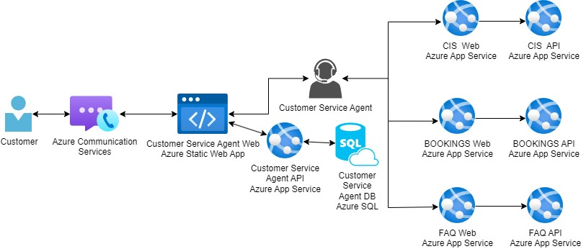

Complex scenario hands-on-lab

Description:
Contoso Suites wants to integrate Generative AI functionality into its Customer Service Agent Web application. They wish to use real-time incoming call audio as prompts for a custom large language model enhanced with the internal FAQ system knowledge base data. The model should provide timely cues to the Customer Service Agent based on the customer's questions and be on the lookout for prompts that indicate a common action, such as account lookup or checking room availability, and execute those actions accordingly. During the call, the agent needs to be able to ask natural language questions about the call and receive context-aware responses. Upon a call's completion, the call's details should be summarized using the large language model and sent to the CIS system. The customer selected Azure OpenAI to implement the Generative AI Functionality.
At the end of this lab, you will be better able to customize Azure Open AI responses by augmenting the model with private internal data and automating the execution of external function calls to perform actions such as data retrieval. Furthermore, you will learn to integrate real-time speech-to-text functionality using Azure AI Services Speech service and use this data as prompts into the customized large language model. Finally, leverage the text summarization capabilities of Azure OpenAI to summarize the call transcript quickly.

Helpful References:
What is Azure OpenAI Service? - Azure AI services | Microsoft Learn
Azure OpenAI Service models - Azure OpenAI | Microsoft Learn
Use your own data with Azure OpenAI Service - Azure OpenAI | Microsoft Learn
How to use function calling with Azure OpenAI Service - Azure OpenAI Service | Microsoft Learn
Azure OpenAI speech to speech chat - Speech service - Azure AI services | Microsoft Learn
What is the Speech service? - Azure AI services | Microsoft Learn
Import an Azure OpenAI API as REST API - Azure API Management | Microsoft Learn

